**Fourier series Representation of Continues time signal**

**LAB # 10**



**Spring 2021**

**CSE301L-Signal $ System**

Submitted by: **Ashfaq Ahmad**

Registration No: **19PWCSE1795**

Class Section: **B**

“On my honor, as student of University of Engineering and Technology, I have neither given nor received unauthorized assistance on this academic work.”

Student Signature: ______________

Submitted to:

**Engr Durr-e-Nayab**

August 13, 2021

**Department of Computer Systems Engineering**

**University of Engineering and Technology, Peshawar**

**OBJECTIVES OF THE LAB**

‐‐‐‐‐‐‐‐‐‐‐‐‐‐‐‐‐‐‐‐‐‐‐‐‐‐‐‐‐‐‐‐‐‐‐‐‐‐‐‐‐‐‐‐‐‐‐‐‐‐‐‐‐‐‐‐‐‐‐‐‐‐‐‐‐‐‐‐‐‐‐‐‐‐‐‐

This lab aims at the understanding of:

* Fourier Series Representation of Continuous Time Period Signals
* Convergence of Continuous Time Fourier Series ‐‐‐‐‐‐‐‐‐‐‐‐‐‐‐‐‐‐‐‐‐‐‐‐‐‐‐‐‐‐‐‐‐‐‐‐‐‐‐‐‐‐‐‐‐‐‐‐‐‐‐‐‐‐‐‐‐‐‐‐‐‐‐‐‐‐‐‐‐‐‐‐‐‐‐‐

**-------------------------TASK 01--------------------------**

* In above example, ak’s are chosen to be symmetric about the index k=0, i.e. ak = a‐k. Select new ak’s on your own to alter this symmetry and form the new signal. What do you observe? Is x(t) a real signal when coefficients are not symmetric?

**Source code:**

clc

clear all

close all

disp('**************Task 01***********');

t=-3:0.01:3;

x0=1;

x1=(1/4)*exp(j*(-1)*2*pi*t)+(1/5)*exp(j*(1)*2*pi*t);

y1=x0+x1;

x2=(1/2)*exp(j*(-2)*2*pi*t)+(1/8)*exp(j*(2)*2*pi*t);

y2=y1+x2;

x3=(1/3)*exp(j*(-3)*2*pi*t)+(1/2)*exp(j*(3)*2*pi*t);

x = x0 + x1 + x2 + x3;

figure;

subplot(3,2,1);

plot(t,x1);

axis([-3 3 -2 2]);

title('x1(t)');

subplot(3,2,2);

plot(t,y1);

axis([-3 3 -0.2 2]);

title('x0(t)+x1(t)');

subplot(3,2,3);

plot(t,x2);

axis([-3 3 -2 2]);

title('x2(t)');

subplot(3,2,4);

plot(t,y2);

axis([-3 3 -1 3]);

title('x0(t)+x1(t)+x2(t)');

subplot(3,2,5);

plot(t,x3);

xlabel('t'); axis([-3 3 -1 1]);

title('x3(t)');

subplot(3,2,6);

plot(t,x);

xlabel('t'); axis([-3 3 -1 4]);

title('x(t)=x0(t)+x1(t)+x2(t)+x3(t)')

figure

subplot(2,1,1);

plot(imag(x));

title('imagnary part of X(t)');

subplot(2,1,2);

plot(real(x));

title('Real part of X(t)');

%we observed that if the cofficient are symmetric then the imaginary part

%will be zero here we consider cofficient non_symmetric so it has imaginary

%part also.

**OUTPUT:**

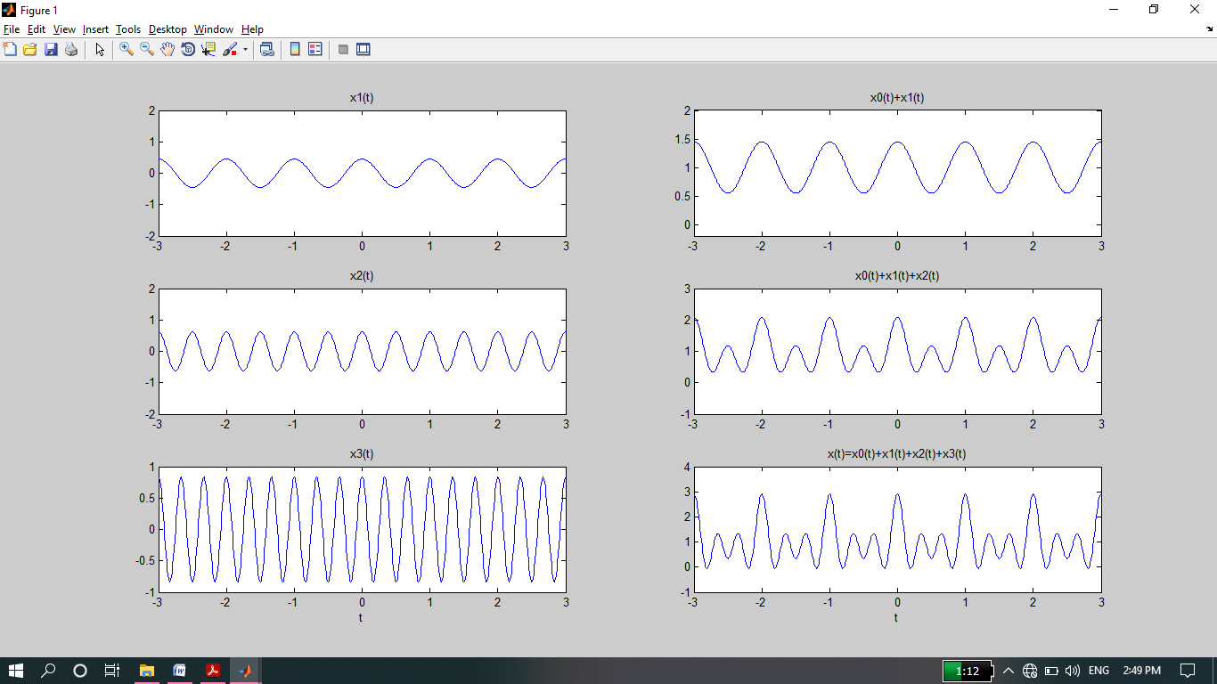

Difference Between Example and Task01:

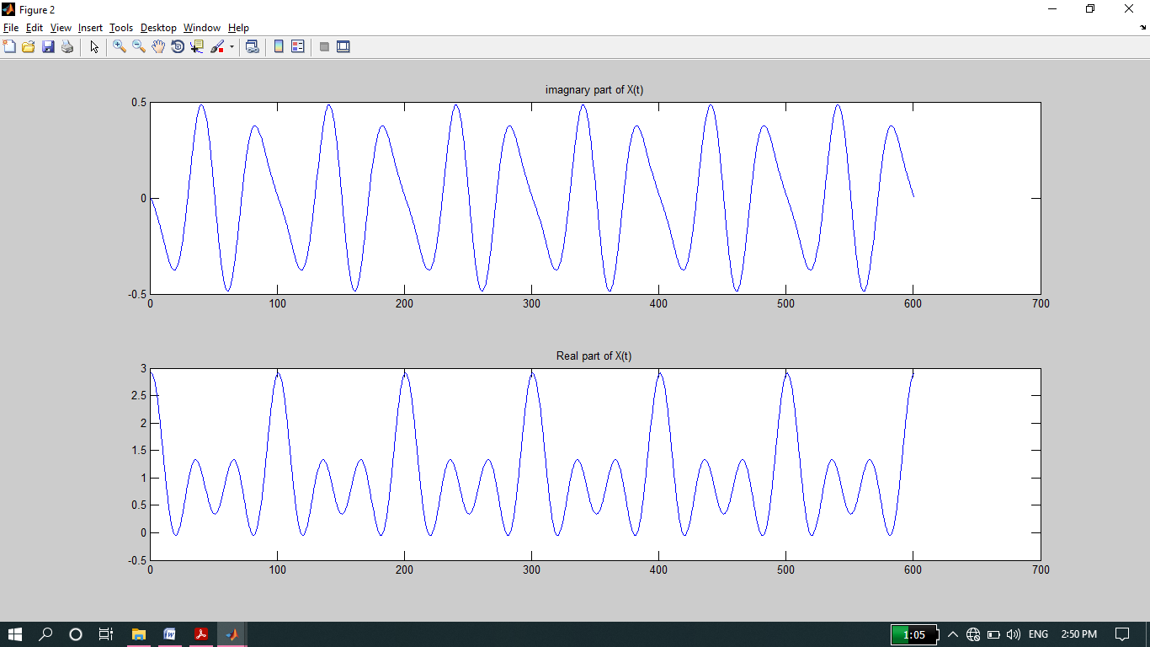

**-------------------------TASK 02--------------------------**

* A discrete‐time periodic signal x[n] is real valued and has a fundamental period of N = 5. The

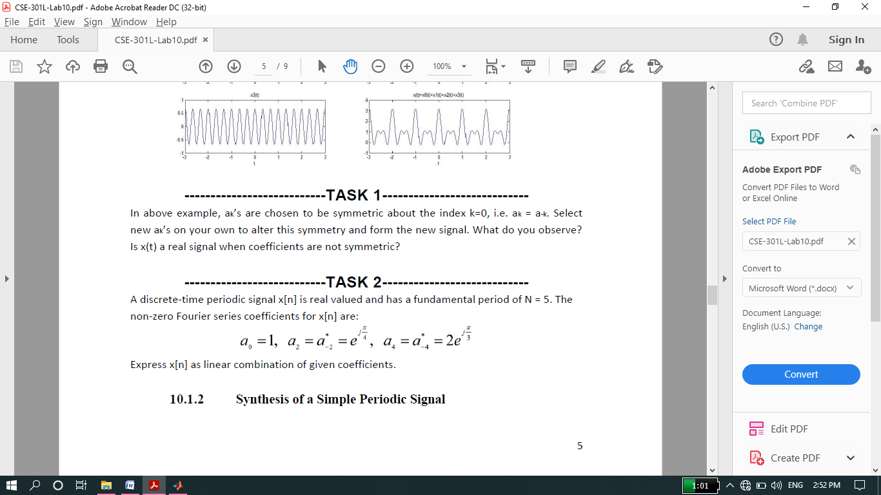

Non‐zero Fourier series coefficients for x[n] are:

Express x[n] as linear combination of given coefficients.

**Source code:**

clc

clear all

close all

disp('**************Task 02***********');

t=-3:0.01:3;

x0=1;

x2=exp(j*pi/4)*exp(j*(-2)*(2*pi/5)*t)+exp(j*pi/4)*exp(j*(2)*(2*pi/5)*t);

y1=x0+x2;

x4=2*exp(j*pi/3)*exp(j*(-4)*(2*pi/5)*t)+2*exp(j*pi/3)*exp(j*(4)*(2*pi/5)*t);

x = x0 + x2 + x4;

figure;

subplot(2,2,1);

plot(t,x2,'Linewidth',2);

title('x2(t)');

grid;

subplot(2,2,2);

plot(t,y1,'Linewidth',2);

title('x0(t)+x2(t)');

grid;

subplot(2,2,3);

plot(t,x4,'Linewidth',2);

title('x4(t)');

grid

subplot(2,2,4);

plot(t,x,'Linewidth',2);

xlabel('t');

title('x(t)=x0(t)+x2(t)+x4(t)')

grid;

**Output:**

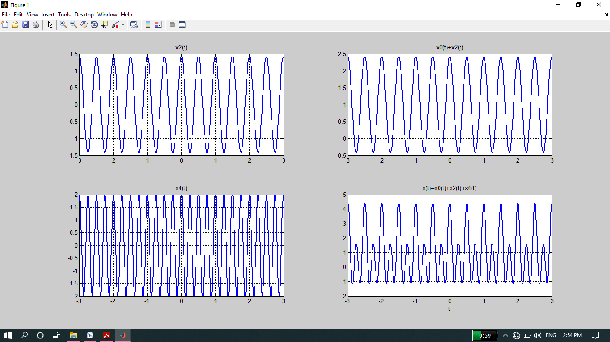

**-------------------------TASK 03--------------------------**

* Considering the FS coefficients plot given below, what do you observe happens to the envelope of the coefficients when T1 is reduced from 1/4 to 1/16 with constant time period T?

**Observation:**

* As T1 is changed from ¼ to 1/16 and we observed that the frequency of wave decrease and time period increase.

**Source code:**

clc

clear all

close all

disp('**********TASK 03*********');

k=-15:15;

T=1;

T1=1/4;

ak1=sin(k*2*pi*(T1/T))./(k*pi);

ak1(16)=2*T1/T;

subplot(3,1,1);

stem(k,ak1,'filled');

ylabel('ak');

title('FS coefficients for periodic Square wave (T=1, 1=1/4)');

T1=1/8;

ak1=sin(k*2*pi*(T1/T))./(k*pi);

ak1(16)=2*T1/T;

subplot(3,1,2);

stem(k,ak1,'filled');

ylabel('ak');

title('FS coefficients for periodic Square wave (T=1, T1=1/8)');

T1=1/16;

ak1=sin(k*2*pi*(T1/T))./(k*pi);

ak1(16)=2*T1/T;

subplot(3,1,3);

stem(k,ak1,'filled');

xlabel('k');

ylabel('ak');

title('FS coefficients for periodic Square wave (T=1, T1=1/16)');

**Output:**

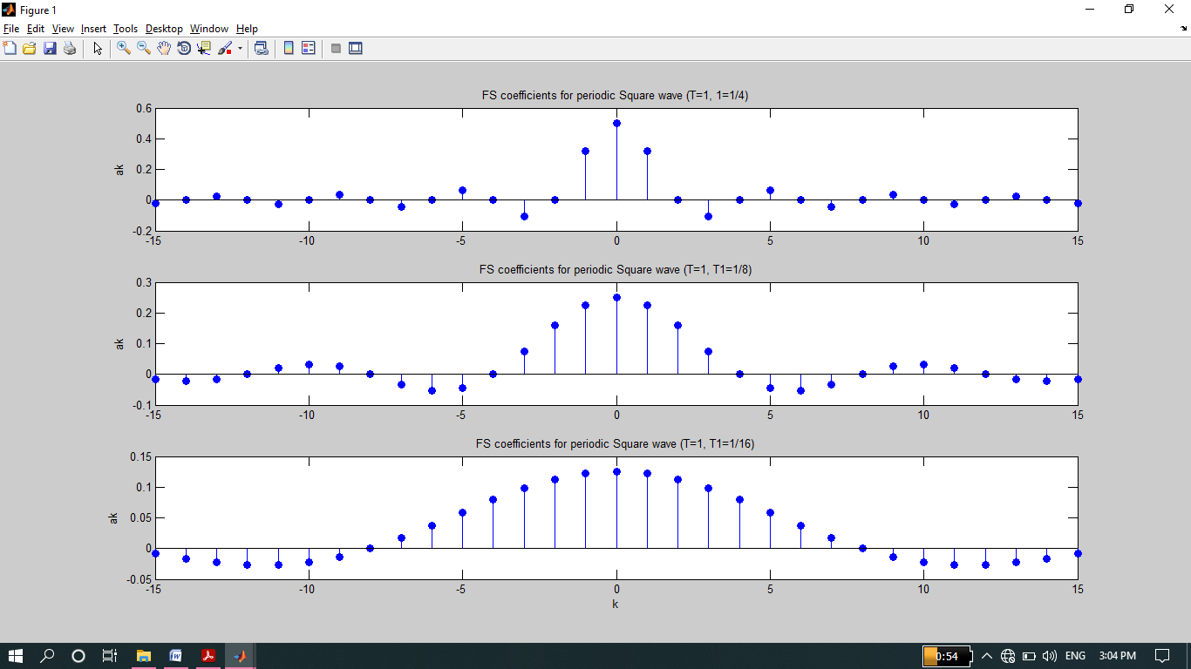

**-------------------------TASK 04--------------------------**

* Create the plots of square wave reconstructed using M = 10, 20, & 100 terms above, what do you observe about Gibb’s phenomena?

**Source Code:**

clc

clear all

close all

disp('***********TASK 04**********');

t=-1.5:.005:1.5;

T=1;

T1=1/4;

w=2*pi/T;

M=100;

k=-M:M;

ak=sin(k*2*pi*(T1/T))./(k*pi);

ak(M+1)=2*T1/T;

x=zeros(1,length(t));

for k=-M:M

x=x+ak(k+M+1)*exp(j*k*w*t);

end

figure

plot(t,x,'Linewidth',2);

grid on;

xlabel('t');

ylabel('x(t)');

title('Reconstruction from Fourier Series, M=100');

M=10;

k=-M:M;

ak=sin(k*2*pi*(T1/T))./(k*pi);

ak(M+1)=2*T1/T;

x=zeros(1,length(t));

for k=-M:M

x=x+ak(k+M+1)*exp(j*k*w*t);

end

figure

plot(t,x,'Linewidth',2);

grid on;

xlabel('t');

ylabel('x(t)');

title('Reconstruction from Fourier Series, M=10');

**Output:**

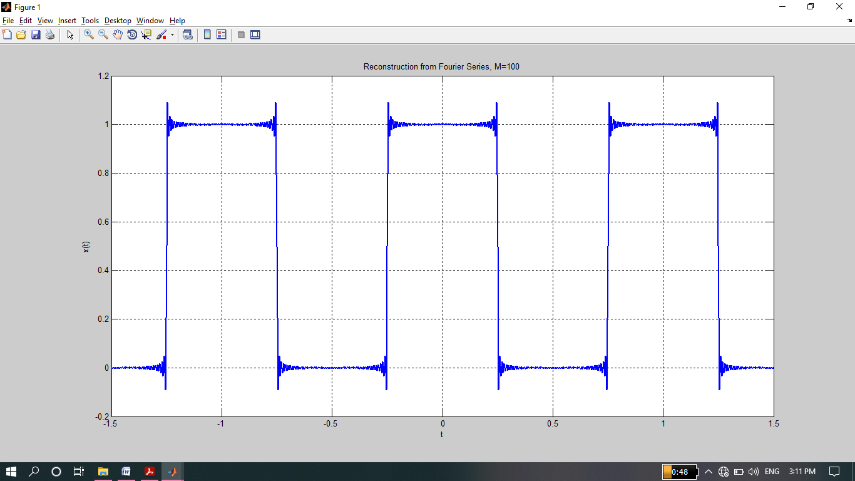

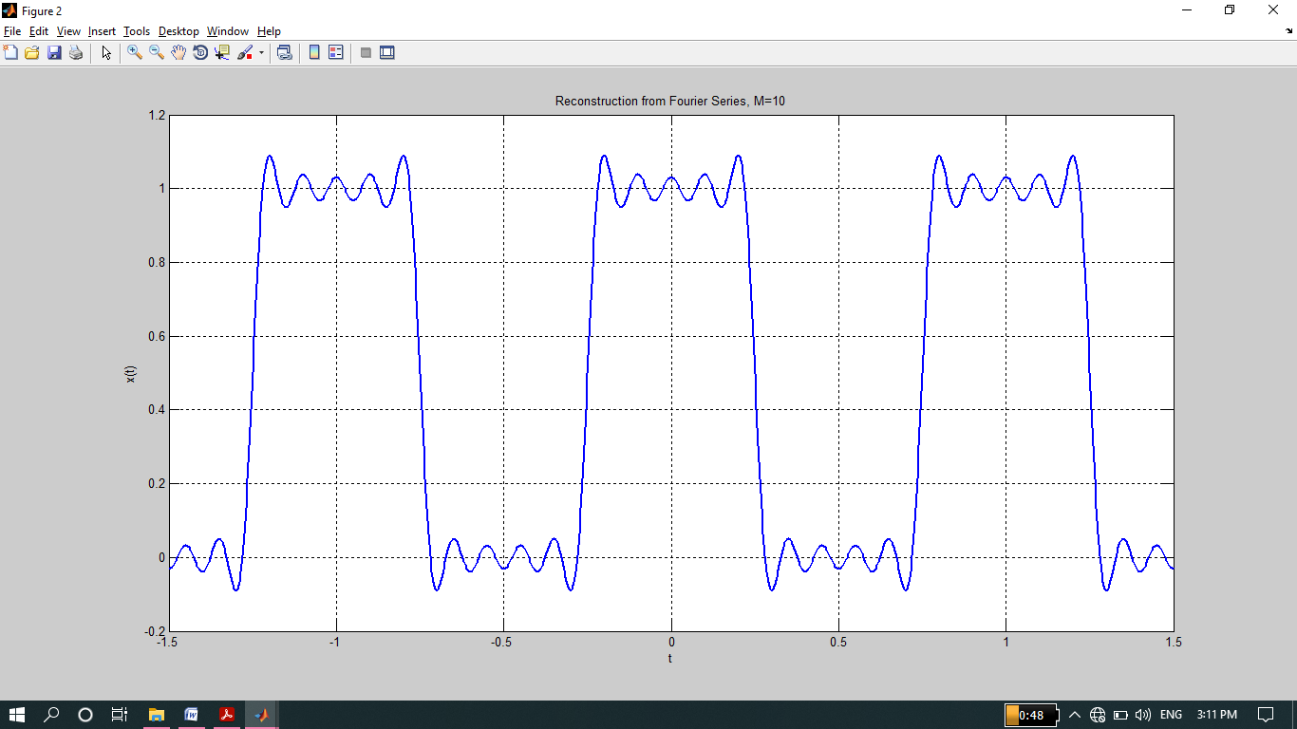

**-------------------------TASK 05--------------------------**

* Given the following FS coefficients:



Plot the coefficients & reconstructed signal. Take the terms for reconstructed signal to be M = 10, 20, & 60. What effect do you see when M is varied?

**Observation:**

* As the no of k increased from k=10 to k=60 so the no of signals will also increase which will added and give us smoothen resultant signal.

**Source code:**

clc

clear all

close all

disp('**********TASK 05**********');

t=-2:.005:2;

T=1;

T1=1/4;

w=2*pi/T;

M=60;

x=zeros(1,length(t));

for k=-M:M

if (mod(k,2)==0)

ak=1;

x=x+ak*exp(j*k*w*t);

else

ak=2

x=x+ak*exp(j*k*w*t);

end

end

figure

plot(t,x,'Linewidth',2);

grid on;

xlabel('t');

ylabel('x(t)');

title('Reconstruction from Fourier Series, M=60');

M=10;

x=zeros(1,length(t));

for k=-M:M

if (mod(k,2)==0)

ak=1;

x=x+ak*exp(j*k*w*t);

else

ak=2

x=x+ak*exp(j*k*w*t);

end

end

figure

plot(t,x,'Linewidth',2);

grid on;

xlabel('t');

ylabel('x(t)');

title('Reconstruction from Fourier Series, M=10');

**Output:**

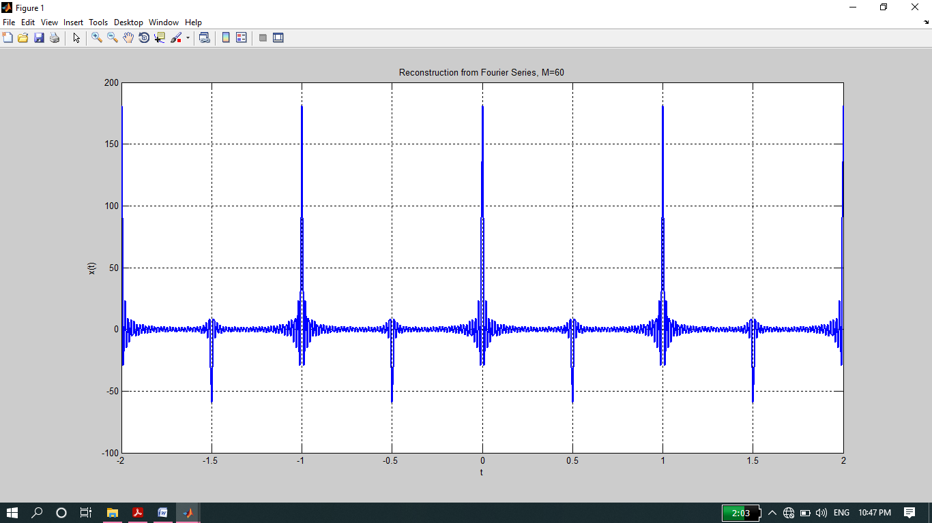

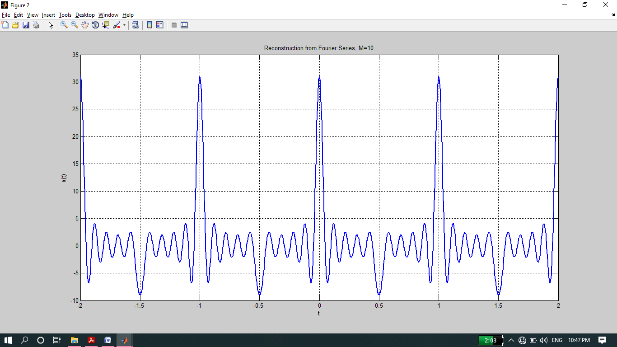

**-------------------------TASK 06--------------------------**

* Given the following FS coefficients:



Plot the coefficients & reconstructed signal. Take 10 terms (M=10) for reconstructed signal.

**Source code:**

clc

clear all

close all

disp('**********TASK 06**********');

t=-5:0.005:5;

T=1;

T1=1/4;

w=2*pi/T;

M=10;

x=zeros(1,length(t));

for k=-M:M

if (abs(k)<3)

ak=j*k;

x=x+ak*exp(j*k*w*t);

else

ak=0;

x=x+ak*exp(j*k*w*t);

end

end

figure

plot(t,x,'Linewidth',3);

grid on;

xlabel('t');

ylabel('x(t)');

title('Reconstruction from Fourier Series, M=10');

**Output:**

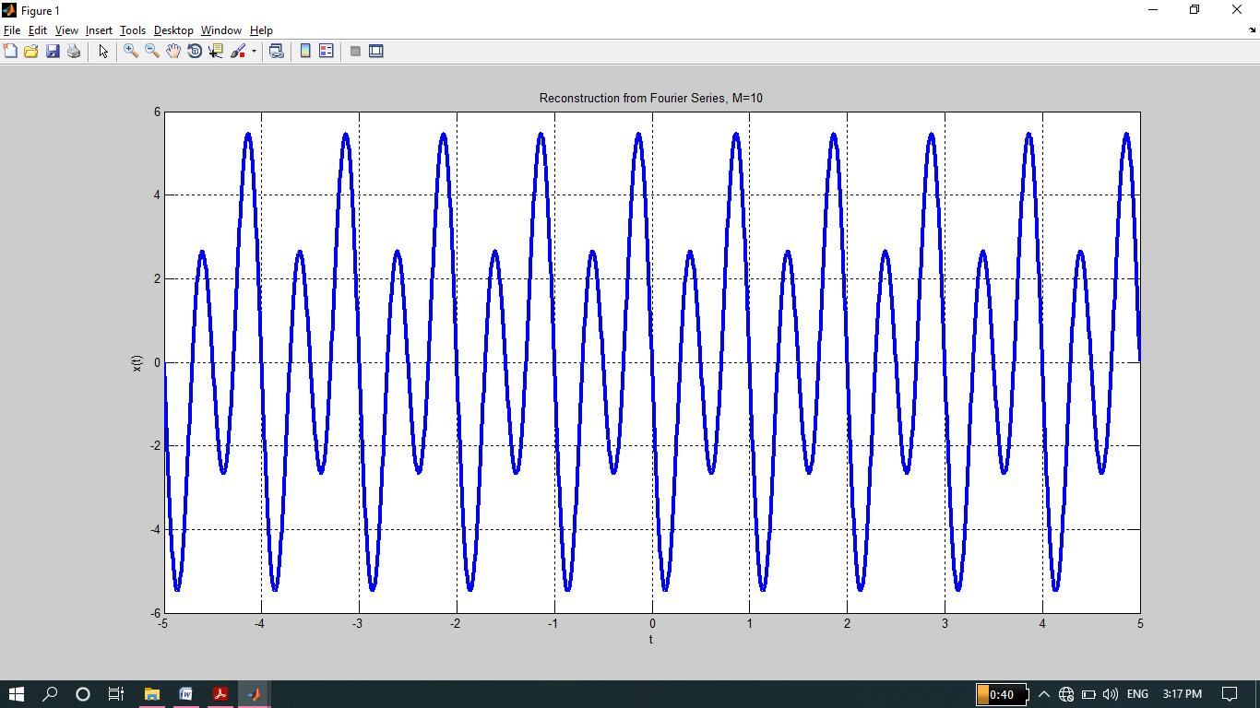

By Ashfaq Ahmad

THE END